**Audio and Data Transfer Through Li-Fi Technology**

**Apurv kumar1,Anshita Yadav2,Mohd Anas3,Ranjeeta Yadav4**

**1,2,3,4,ABES Engineering College,Ghaziabad,UttarPradesh,India**

**Abstract----**For the purpose of transmitting audio data via electromagnetic radiation Communication (VLC), the Light Fidelity (Li-Fi) technology was developed.The development of a faster and safer method for transmitting data is the goal of this project short-range wireless technologies like Bluetooth and Wi-Fi are currently used in a lot of wireless applications.There are a number of issues with these current technologies, including data insecurity, increased power consumption, and increased costs.As a result, there is a significant demand for new technology that can address all of these issues.VLC is a promising new alternative technology. Li-Fi has a number ten thousand times greater than the spectrum of nonparticulate radiation to operate in the sunlight.Instead of traditional radio waves, it transmits using electromagnetic radiation because of this it is used in places where radio waves cannot be used due to its extremely high speed (ranging from 3 to 108 meters per second), light is also a source for high-speed communication requirements.The light is occasionally aligned, but the sun's rays are diverted by changes in the atmosphere.Information rates of Multiple Gigabits per Second could also be transmitted over a short distance with VLC's 300 THz bandwidth.Here, a prototype of a VLC that transmits data at a significantly higher rate and over a significantly greater distance is being developed.This prototype demonstrates the audio transmission capabilities of VLC.In this paper, a real-time audio broadcast prototype using commercial LED lamps is shown.According to the findings of the experiments, it is possible to transmit real-time audio over a distance of up to 2 feet with the right arrangement of LED sources and effects that improve theconcentration.The lighting model's construction and simulation in the real world demonstrate of connection between the illumination source's layout and distribution.

**Keywords**: Arduino Uno, ISD 1820 Voice Recording Module , Amplifier Circuit , Speaker

1. **INTRODUCTION**

In the modern era, there has been a significant demand for data accessibility. We genuinely want to interface with the web. The requirement for internet access has increased in importance as a result of the emergence of numerous new technologies like machine learning (ML), cloud computing, artificial intelligence (AI), and the internet of things (IOT), among others. A low-pass filter is a type of filter that attenuates signals with frequencies higher than the cutoff frequency and passes signals with frequencies lower than a predetermined cutoff frequency. The design of the filter determines the exact frequency response. In audio applications, the filter is sometimes referred to as a high-cut filter or a treble-cut filter. A low-pass filter is a high-pass filter's companion.The issue is getting even worse as a result of RF interference. Light Fidelity (Li-Fi) makes use of the visible light spectrum that is not being used by making use of Light Emitting Diodes (LEDs) as light sources. Second, visible light is limited to the radio frequency that is used the most frequently in wireless communication because light waves cannot pass through obstacles.A single room or a hallway, the researchers must address the security concerns of the physical layer in order to solve this problem.Finally,light communication can transmit data, but it is limited in comparison to radio waves. However, the technology has a lot of room for improvement, and Li-Fi technology can overcome the limitations.To put it another way, a single data point can besent.In the compression of radio waves light communication can transmit data with some limitations. A channel access method (CAM) called time division multiple access (TDMA) is used to allow channel sharing without interference. By dividing signals into distinct time slots, TDMA enables multiple stations to utilize the same transmission channel and share it with one another. Each user uses its own time slot and transmits in rapid succession. As a result, a frequency channel may be shared by multiple stations, similar to mobiles, but only a portion of its capacity is utilized.Despite the fact that Li-Fi technology has undergone significant implementation and development around the world.The technology has a lot of room for improvement, and Li-Fi technology can overcome its limitations.This growing significance has been a significant factor in the worldwide demand for LEDs.To put it another way, a single data point can be sent.There have been significant advancements in Li-Fi technology despite its extensive global implementation and development. The Arduino Uno is a type of open-source board that includes an ATmega328p microcontroller. It is available for purchase. The Arduino Uno has an input and output set of analog and digital pins that are used to connect the board to other parts. There are fourteen inboard I/O pins, six of which are analog input pins. The board can be connected to a power supply via a USB connection. In electronics projects, the board is used to design the circuit.The benefits of driven correspondences, especially in short-range correspondences incorporate a more extended life expectancy further developed proficiency, minimal expense, and low support.Companies in developed nations like Japan, the United States, China, and others frequently employ them.In addition, demand for LEDs and Li-Fi technology has steadily increased. The Arduino board is built on top of an ATMEL AVR microcontroller. The integrated circuits known as microcontrollers enable the recording of instructions written in the programming language that is supported by the Arduino IDE environment. Programs that interact with the board's circuitry can be created with these instructions. The Atmega168, Atmega328, Atmega1280, and ATmega8 are the most frequently utilized microcontrollers on Arduino platforms due to their simplicity. However, Intel and Atmel microcontrollers with 32-bit ARM architecture are being added at the moment. The Arduino microcontroller has communication ports in addition to input and output ports. which makes it possible for us to connect a wide range of board-based peripherals. The data from the peripherals you connect will be received by the microcontroller, which is in charge of processing the data. On the other hand, the software we get from Arduino consists of a bootloader that runs on the board, a development environment (IDE) that uses the arduino programming language, tools to transfer firmware to the microcontroller, and so on. The primary feature of the software and programming language is their simplicity and ease of use.

Two technologies for short-range communication are Bluetooth and Wi-Fi. In these technologies, communication relies heavily on visible light; for radio frequency communications to have a higher bandwidth and data rate, visible light must be used.The infrared, visible, and ultraviolet spectral ranges are covered by Li-Fi frequencies and wavelengths, respectively.Li-Fi is a useful addition to the technology for short-range communication that is already in use.Visible light, like all other wave propagations, can also communicate through waves. Depending on the energy level, the energy can either degrade or be terminated by the medium that is provided.We are aware that a photon, which denotes the quantum of light, is used to describe the transferred energy.The energy of light waves is concentrated in a single location when photons absorb them, a phenomenon known as wave function collapseLight comes from here. The term duality of wave and particle" refers to this duality between waves and particles. The speed of light in a vacuum is about 299,792,458 m/s, In a vacuum, each type of electromagnetic radiation travels precisely at this speed. In order to improve user comfort and customer satisfaction, location-based services (LBS) are being developed simultaneously with other location-based services. The services that the Global Positioning System (GPS) provides for outdoor navigation are excellent. The Root Mean Squared Error (RMSE) is one of the two primary performance indicators for a regression model. The average difference between the actual values and those predicted by a model is what it measures. The model is better if the Root Mean Squared Error value is lower. It estimates the model's accuracy, or ability to predict the target value. A hypothetical model that would always predict the exact expected value would have zero Root Mean Squared Error. These services include information about transportation options and traffic conditions. Over the past few decades, Visible Light Technology has advanced rapidly. In comparison to frequency communication, Visible Light Communication (VLC) offers numerous advantages. There are a number of advantages to using visible light communication over the more common RF communication. First, the bandwidth in the visible, infrared, and ultraviolet spectral bands is unrestricted and unlimited. However, the spectral scarcity and overcrowding of the spectral bands necessitate the creation of a new mode of communication and solutions to practical research issues.

1. **RELATED WORK**

This section provides a general overview of Li-Fi-related university and research groups and discusses the various studies that have been conducted as well as advancements in indoor navigation and Visible Light Communication (VLC).Takakuni et al.In wireless communications.According to research [2], batteries employ fewer optical methods.White LEDs can send data over a maximum distance of 40 centimeters at a speed of 100 kilobits per second.Using these transmitters and photoelectric cell at the receiver to simulate visible light, the optical layout schemes and their effectiveness in this communication were demonstrated.

In [3], sound waves or sound signs are communicated utilizing Li-Fi innovation.The white LEDs are utilized for information transmission by utilizing their unique properties and the LEDs' interacting activitiess shot by me..A mobile phone is used to send data and send sound signals using a system that involves the photograph diode and transmits information in an electrical signal structure.The First Ordered Low Pass Filter has been utilized to demonstrate this procedure.

The researchers followed a method that involved installing an Ip Network in a single room. The algorithmthey used helps visually impaired people use their smart phones to get to their destination from a restricted location. The authors of [4] recommended using Li-FI technology for indoor communication; this strategy, which assists in interior navigation, may be advantageous to those with visual impairments.A low-data-rate device-to-device communication system is demonstrated in this paper [5]. LED light bulbs, which serve as the system's foundation, are outfitted with photo diodes and microcontrollers. Allows-information rate (up to 600 bps) correspondence administrations inside a room, it comprehends to fills in as the establishment for different applications.

According to the researchers' description of light-weight communications in [6,] LEDs are utilised to communicate acknowledgements by flashing the LEDs at a light-weighted pace that is invisible to the human eye and does not interfere with visual communication. However, because there are no commercial aspects, there are numerous research opportunities and potential advancements in this field.

This aspect employs multi-path-induced concepts through multi-path reflections, and it appears that indoor navigation accuracy has improved. According to [7], a root mean square error was gathered and analyzed. The bright technology of visible light communication enhances indoor navigation and lends itself to a wide range of uses.

The author [8] has looked into the improvements that will need to be made in the future when using wireless andinfrared communications. These advancements, for instance, may replace imaging receivers with a single element type. Concerning imaging receivers and Line of Sight for a multibeam transmitter, the researchers have addressed IR link issues.

The way the system is put into use is shown in [9], which helps visually impaired people become more unique and less dependent on applications for indoor navigation.In the method, the GPS is used to find obstacles and avoidances of objects.The authors are also working on developing the Zig-bee Protocol for visually impaired individuals.The interactive nature of the communications is supported by the audio signals.

The use of acoustic sensors and the TDMA Scheme for indoor navigation was the primary focus of the research that was presented in [10].The appearance of the time and its estimations utilizing four of the transmitters act as the establishment for the beneficiary's technique.

According to the author [11], the broad and quick advancement of portable technology spurred researchers to efficiently develop a wide range of applications.Shoppers can now use a new smartphone app to navigate shopping malls.The data from the accelerometer are used in the proposed system.In order to demonstrate its suitability for indoor retail store navigation in terms of availability, dependability, and accuracy, the proposed cart's performance was evaluated in a variety of test scenarios.

1. **PROPOSED WORK**

*A .OBJECTIVE*

The transmission of data through LEDs is the fundamental principle of Li-Fi. When used as a light source, LED bulbs can transmit data through visible light at constant current LED flickering has an impact on the transmission speed as well as the flow of data when data 1 is transmitted LED turns on when zero is transmitted, it turns off. Variable light frequencies encode the data and strings of one and zero turn the LEDs ON and OFF, respectively.

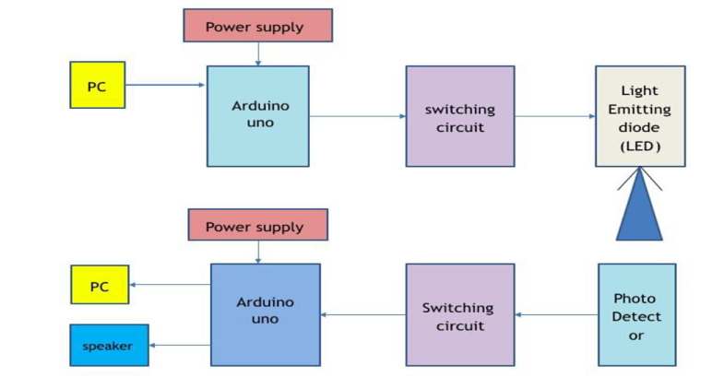

Fig 1 Block Diagram of Transmitter and Receiver Section

A Li-Fi trans-receiver’s fundamental operation.It transmits an electrical signal to an LED driver from an input device.The photodiode receives this electrical signal in the form of light as binary data.After that, the light signal is recognized by the receiver, and the data that is sent to the output device is decoded.

In our project, laser light is used to send audio and data to the solar panel for audio signal transmission, the positive end of the laser is connected to a 5 volt supply;An audio device's aux cable is connected to the laser's ground end;The signal's amplitude changes are send to the solar panel, and the solar panel's output is connected to an amplifier circuit that is connected to the speaker for the purpose of transmitting data, the laser source is connected to the Arduino Uno microcontroller the text data is converted into digital output for the solar panel in the forms of 1 and 0.On the receiving side, the analog pin of the Arduino uno is connected to the solar panel's analog output.If the value exceeds the defined threshold, an Arduino threshold value is set for the analog signal is set to 1 and if it is less than the defined threshold it is set to 0.After The data is decoded into text when it is received, and it is displayed on a serial monitor or LCD display.

A mobile device sends the audio signal to the transmitter, and an array of LEDs send the analog signal.The one shown in Figure 1 effectively alters the amount of sunlight that is emitted.Utilizing the various light intensities, the photo diode records the signals., the pre-amplified speaker amplifies the signals received by the solar battery through the unsteady junction rectifier array and then emits sound waves that the speaker can detect.Figure 1 illustrates how this is demonstrated.

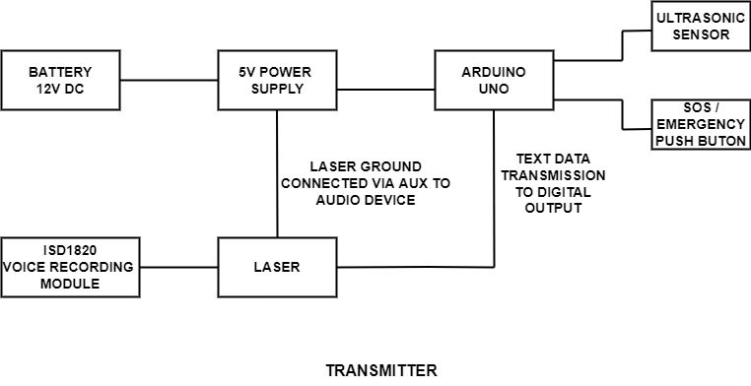

Fig. 2: Audio & Text Transmission

A voice recorder is used to first record the voice to ensure that the information that will be transmitted is prepared.The transmitted side will then interpret the recorded voice that needs to be transferred.The voice is received by the little controller on the transmitter side, where it is coded in order to proceed with the further step.When the code is finished, it will be transferred to the device where the voice in coded form is completely converted to light structure.The data are then transferred to the receiver side once they are within the light's range.After that, the coded voice is decoded and sent to the receiver's output.Consequently, the output is received by the speaker on the receiver side.

*B. TEXT TRANSMISSION*

In accordance with the user's requirements in the transmitter section, the Arduino IDE handles the initial text input from the laptop.This message is transmitted to the led by means of an Arduino Nano microcontroller.In the receiver section, a photo transistor and a photo receiver diode are connected an Arduino Nano microcontroller and laptop are connected to this via a USB to serial port converter.Diagram 2shows how this is demonstrated.

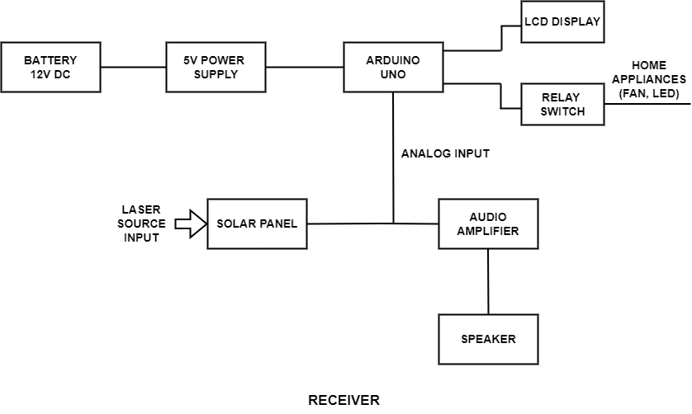

Fig. 3:Audio &Text Receiver

To keep the issue ready for transmission the text is initially typed onto a device such as a laptop, mobile phone, or other device. The work on the transmittal side will then conform to the text that needs to be transferred.In the figure above the text is sent to the small controller on the transmitter side.In order to move forward with any process the text is coded during a type.After the code has been prepared it will be sent to the convertor where the coded text is converted to light type.When the light is placed in the range the data can transferred to the receiver side.The coded text is then decoded and sent to the output of the receiver.Therefore the output is obtained at the source and is available at the receiver.

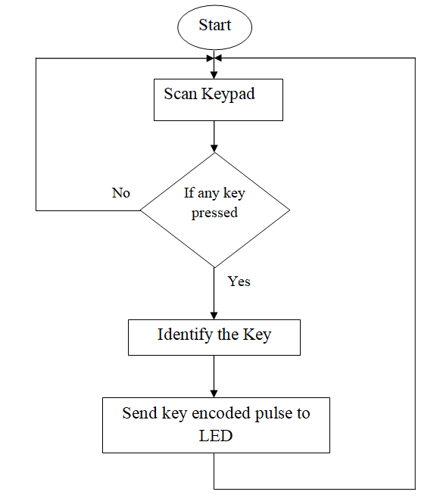

Fig 4.1 Transmitter Flow Diagram

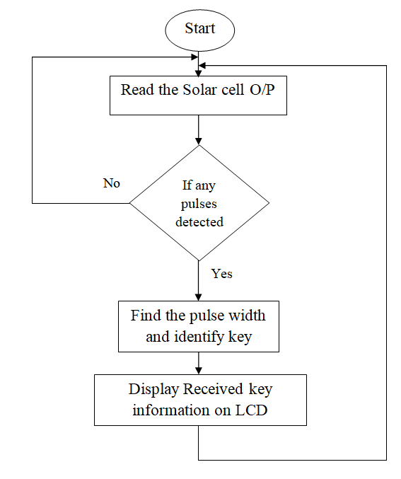

Fig 4.2 Receiver Flow Diagram

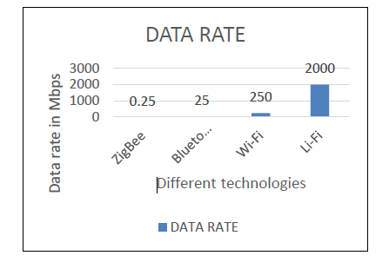

Fig 5.An examination of the data rates of various wireless

Communication technologies in comparison

1. **CONCLUSION**

We were able to transfer the temperature-recorded voice and text to the receiver side with the assistance of a transmitter-side light source.The text is displayed precisely, the temperature is accurately detected, and the speaker makes an appropriate sound.This innovation has a tremendously impressive future.In this section, we demonstrate how visible light can be incorporated into a communication system.This system can be used with the infrastructure that is already in place without requiring significant modifications.Visible Communication is a rapidly developing technology in the field of wireless communications because there are a lot of challenges in this field, but there are also benefits that are equal or greater.Many of the problems we've dealt with for a long time, like power and natural resources, might be solved by using VLC.Although the VLC is still in its infancy, the quick developments that are being made to this technology on a stage by stage basis will soon see it employed in our daily life..We believe that the VLC system will become one of the most promising and well-known wireless communication technologies for future generations, despite the research's flaws.Due to its shorter range, Li-Fi is more secure than Wi-Fi, but embedded light beams reflected off a surface can still achieve 70 megabits per second, according to reports.Despite having a secure connection, Li-Fi is constrained and cannot penetrate walls, unlike Wi-Fi.Unsecure radio frequency communication and radio frequency-based wireless communication, both of which can be impacted by electromagnetic field (EMF) interference and pose health risks, were the focus of this project.In this project, an Arduino and Li-Fi Technology-based wireless data transmitter and receiver device was successfully designed and implemented.

**5.REFERENCES**

1. Harald Haas is the best. Harald Haas: Wireless data is received by every light bulb.2018.
2. NikshepK. N. and Sowmya G. wrote the article "Voice and Data Communication Using Li-Fi" that was published in the International Journal of Advanced Computational Engineering and Networking. October 2016, Volume 4, Number 10, ISSN: 2320-2106.
3. Fuada, Syifaul; TrioAdiono; TheYulianAskaandAngga Putra Trans-impedance Speaker (TIA) Plan Utilizing Financially Accessible Over powered AMP for Noticeable Light Correspondence (VLC).
4. A scheme for autonomous blind human navigation using fuzzy image processing, soft Computing as Applied, 7.257-264, 2007.10.1016.
5. Rohan Kapoor, AllesandroGardi, and Roborto Sabatini's article titled "A Multistatic Ultrasonic Navigation System for GNSS-Denied atmosphere AIAAA Scitech 2019 Forum, 2019.pp.1930"
6. SapnaMamidkar and RasmiranjanSamantray's "A Survey on Li-Fi Technology and Its Applications" appears in International Journal of Science and Research, Volume 7 Issue 7, July 2018, pages 1388-1392.
7. WenjunGu, Mohammadreza A. Kashani, and Mohsen Kavehrad's study, "Multipath Reflections Analysis on Indoor Visible Light Positioning System," was published in IEEE Globecom on April 6, 2015.
8. Dr. Boyina, HariPrasanth, Ms. K.Deepa, and S. RaoVivek, L.Nanda Kumar, S. Rajendhiran, S. Saravana, and A.J., published "Indoor Navigation System For Visually Impaired Person Exploiting GPS" in the International Journal of Advanced Engineering Technology, Volume III, Issue II, April-June 2012, pages 40-43.
9. RohanKapoor, AllesandroGardi, and Roborto Sabatini.2019 A Multistatic Ultrasonic Navigation System for GNSS-Denied atmosphere.pp.1930.
10. Natesan Palanivel and Tingsu Chen, "Wiring Harness Reduction in Automotive Using Lifi Technology," February 22 , 2018.
11. D. Andrade, J. P. Gomes, and P. S. André, "Execution of a Noticeable Light Correspondence Connection: Smartphone Li-Fi DOI: "2019," 10.9790/2834-1703015258 www.iosrjournals.org 58 .
12. Mrs. M. Prathibha, M. Sharmila, M. Shrin Shifana, V. Theebica, and V. Sangeethapriya's audio transmission over a lifi system in April 2018.
13. Anaa Vega, July 14, 2014 Drove lights are utilized in the Li-Fi record information transmission of 10 GBps." The Engineering and Technology Magazine was found on February 15, 2015.